

**American International University-Bangladesh (AIUB)**  
**Department of Computer Science**  
**Faculty of Science &Technology (FST)**

**Spring 2021-22**  
**CSC 2210 Object Oriented Analysis and Design (OOAD)**

**Section: F**

# Project Title: Merlin Flight Management System

**Submitted By:**

SARJAT AZIZ RUMI(19-40595-1)

S. S. M. AFSAN SANI (19-39332-1)

**Submitted To**

VICTOR STANY ROZARIO

ASSISTANT PROFESSOR

DEPARTMENT OF COMPUTER SCIENCE

FACULTY OF SCIENCE & TECHNOLOGY

**Merlin Flight Management System**

## Introduction:

A Flight Management System (FMS) is made up of two parts: a computer and a control display unit. (FMS) can compute all necessary elements of an entire flight utilizing navigation and performance databases kept in the unit, as well as data provided by the pilot. Pilots interface with the system by utilizing one to three similar Multipurpose Control and Display Units (MCDU). Merlin now offers TCDUs (Touch Control and Display Units) for added convenience. The FMS reduces the pilot's workload. The FMS's navigation functions Modern aircraft may still navigate utilizing techniques established during the early days of instrument flight. Honeywell began developing its flight management system (FMS) in 1978, and the first FMS became standard equipment on the Boeing B757 and B767 in 1982. Every major aircraft manufacturer now incorporates a Honeywell FMS within the cockpit. R&D is already ongoing for new and improved technologies such as 4D trajectories, future air navigation systems, needed time of arrival, and trajectory-based optimization.

**Company Description:**

The name Merlin was named after Britain's smallest falcon-like bird, "Merlin." Place designers were influenced by its fast flight capabilities and aerodynamic body. Rolls Royce, the parent company, began manufacturing automobiles in 1904. During WWI, the business began constructing aircraft at the request of the British Air Ministry, and the Merlin Series planes were the wonder machines that won the war with their famed Merlin Engines. During World War II, the company manufactured a total of 168,000 units for RAF dogfights and bombing campaigns. Merlin also has plans to build shadow or underground factories around the country in response to the Luftwaffe's massive bombing raids. The British government adopted the approach as well. For commercial and military purposes, modern Merlin planes have FMS (flight Management Systems).

## Justification:

1. Merlin FMS is designed in a way to support commercial and military fleets. Old aircraft of the world war does not fall under these criteria.
2. Overall reduction of time and cost to develop, implement, and test new functionality.
3. The continued cycle of development to meet current and future airspace management standards.
4. Created optimized flight paths, 4D Trajectories, lower sound intrusion, lower emissions, and best fuel consumption.
5. To maximize Human and Cargo Safety, Minimize cockpit workload.
6. The modular design approach and flexible capabilities of FMS enable Merlin FMS to quickly respond when airlines or military operators request additional features to secure their unique applications.
7. Merlin FMS also enables future work with data management and analytics.
8. Merlin offers an easy solution to FMS software components that enable easy implementation across many different aircraft programs.
9. R&D helps Merlin FMS to lower the cost of acquiring new functionalities.
10. Merlin FMS flexibility and usability are further enhanced with touch control display units [TCDU (Touch Control Display Units)] instead of button pressing CDUs [Control Display Unit] which provides information and control of a wide range of aircraft systems with a mere touch of a finger.
11. Advance FMS of Merlin enables safety systems and ensures flight journey with confidence and secured investment for Investors all over the world.

**Scenario-1:**

**Flight Planning System:**

It is now the conventional requirement of modern airspace that all pilots need to file a flight plan or additional set of flight plans with VFR (Visual Flight Rules) planning to ensure safety and standards are met. Where VFR flight plan is associated with search and rescue operations. The pilot can submit flight plans from Flight Service Station Agent or through the website 1800wxbrief or by communicating with Flight Service Station Radio Operators. It is crucial for the flight plan to be verified and approved before putting its information into the FMS (Flight Management System) for in-plane data analytics and connecting with all other systems like ATCs [Air Traffic Control] and AOCs [Aircraft Operation Center]. Before a flight or in mid-air, flight plans can be submitted and updated and any other type of assistance can be asked through radio communication on specific frequencies from the VOR station information list. Any type of complications during and after flight needs to be addressed to the Flight Service Station Operators and in-flight report. VFR safety plans always need to be canceled if a safe landing is confirmed by the pilot to the Flight Station Service personnel.

**Use Case 1 from scenario**:

The pilot must create an account in the 1800wxbrief flight planning system. The pilot can create an account and needs to be verified before logging in to the website and proceeding further. The pilot can also contact the flight service station agent to submit the flight plan. The pilot must go through brief and climate information before planning. After that the website system will show a form that the pilot has to fill in before submission. The pilot must submit an additional flight plan called the VFR [Visual Flight Rules] flight plan in the system site before flight or during mid-flight. The pilot can submit a flight plan before taking off or during mid-flight through radio communication with Flight Service Station operators. All flight plans are verified by AOC (Aircraft Operation Center) before it is inserted into FMS [Flight Management System]. The pilot must cancel the VFR flight plan every time before safe landing through communication with Flight Service Station Operators and when confirmation is received, the Pilot completes a safe landing and files a successful landing report.

**Use Case Diagram - 1**

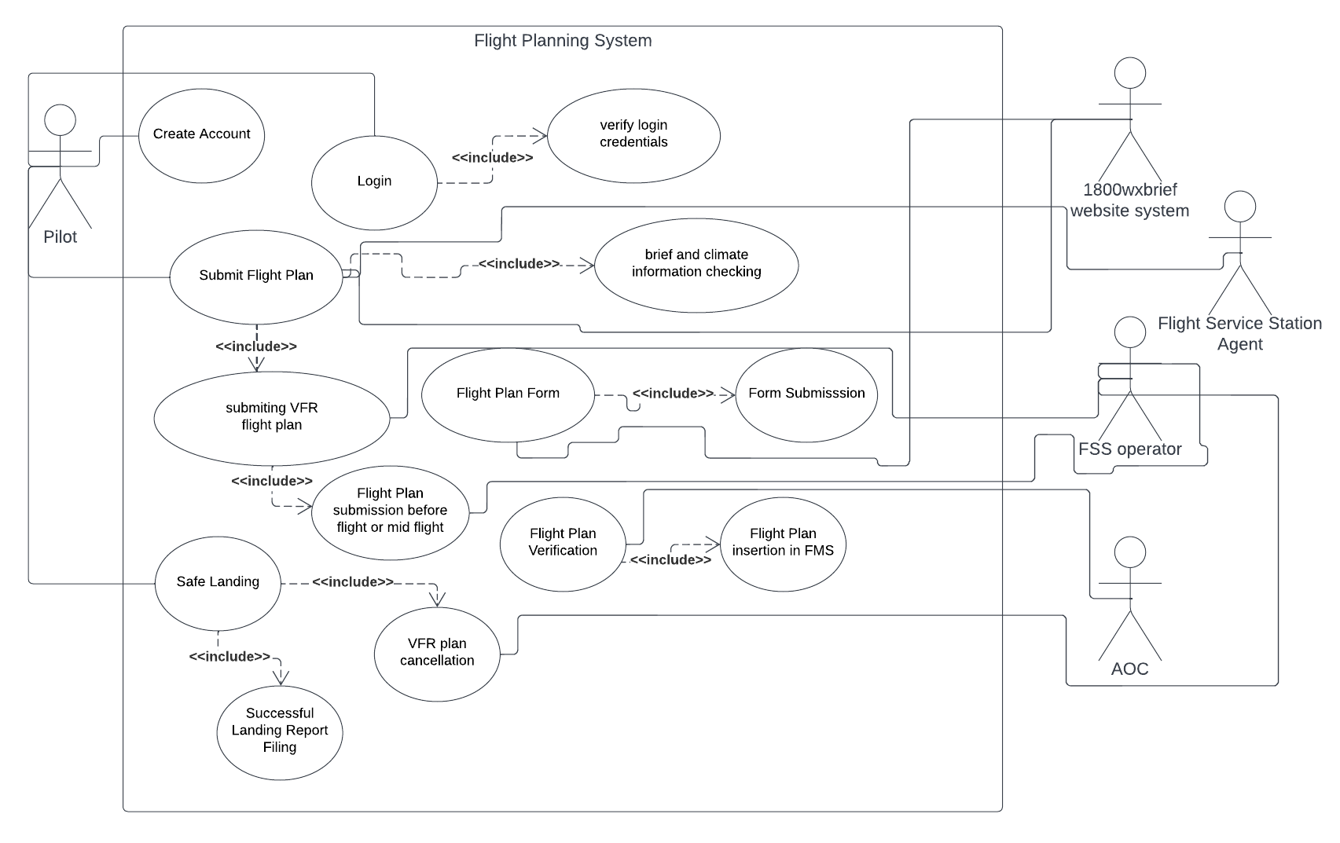

**Sequence Case 1 from scenario:**

In a flight planning system of Merlin Airlines, a pilot can place a flight plan to the Merlin Flight Service 1800wxbrief system. Before the pilot submits the plan, the pilot's license status must be verified whether he is allowed to fly or not. The flight plan must go through AOC [Aircraft Operation Center] and ATC [Air Traffic Control] to get verified. After successful verification, the system prints out the flight plan in paper format. An alternative Flight plan can be submitted in midair using radio communication with Flight Service Station. The verification/confirmation will be announced from Flight Service Station through radio to the pilot. When the pilot reaches a safe destination, right before landing, he must verify and cancel the VRF flight plan through the Flight Service Station and get a confirmed cancellation and then can land on the runway successfully.

**Sequence Diagram - 1**

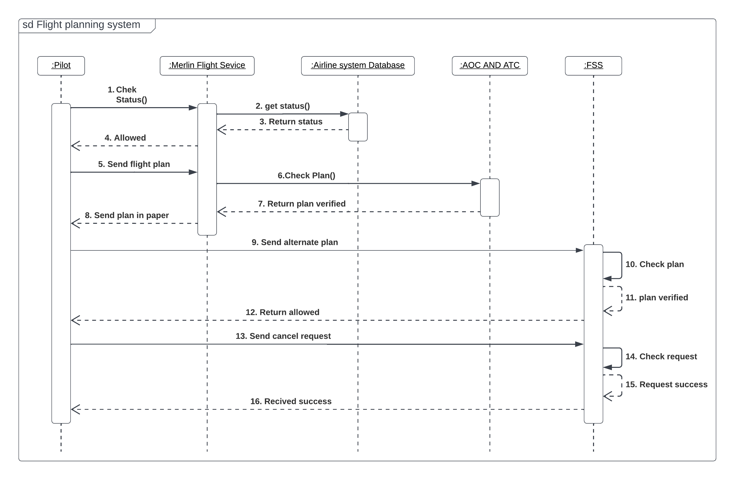

**Activity Case 1 from scenario:**

In a flight planning system of Merlin Airlines, a pilot can place a flight plan to the Merlin Flight Service 1800wxbrief system. Before the pilot submits the plan, the pilot's license status must be verified whether he is allowed to fly or not. After the verification, the flight plan must go through AOC [Aircraft Operation Center] and ATC [Air Traffic Control] to get verified. While the flight plan is verified, the system creates an object and saves it in the control server at the same time. After successful verification, the system prints out the flight plan in paper format. If the flight is not verified, then the pilot again must submit the flight plan before departure. The pilot can submit an alternative flight plan using radio communication with Flight Service Station. The verification will be announced from Flight Service Station through radio to the pilot. When the pilot reaches a safe destination, right before landing, he must verify and cancel the VRF flight plan through the Flight Service Station and get a confirmed cancellation and then can land on the runway successfully.

**Activity Diagram - 1**

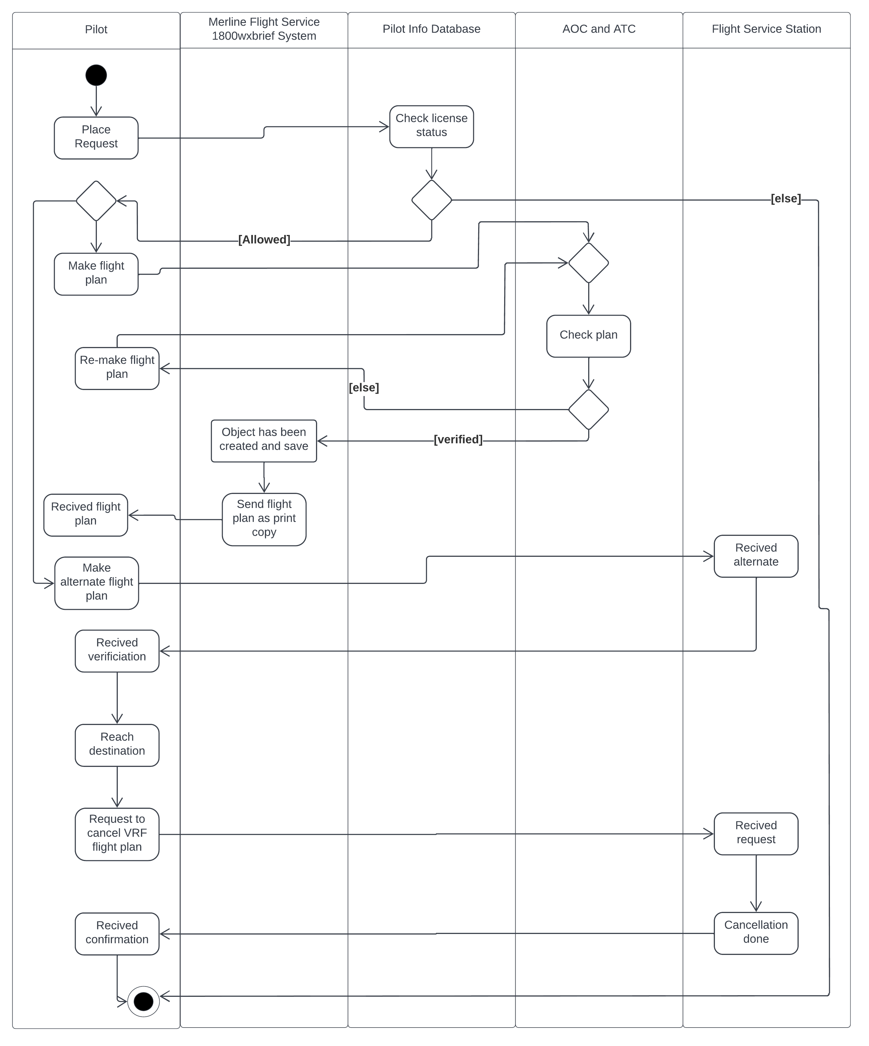

**Scenario-2:**

**Flight Network Management:**

Flight network management makes sure that flight makes their way to the destination safely and smoothly as possible. Network management officers check the flight plan that the airline sends in and make sure the plane is following the rules. So, each flight plan was distributed to all air traffic control centers to fly over. That process happens before the flight has even taken off. Once the plans are approved the plane is fueled, loaded, and ready to go, the pilot will get approval from the departure airport and ground control to push back. Ground control is responsible for navigating all the vehicles and planes safely across the apron up until they reach the runway. The moment an aircraft gets to the runway, they are then the responsibility of Tower Control which, assuming all is well, clears them for takeoff. As the plane reaches altitude, it will be passed off to the departure airport Terminal Control navigates aircraft through the complex area airspace until they reach 24,500 feet (about 7.47 km) or flight level 245 which for this flight should be about when it reaches the coast. From there, they will be transferred to the Dispatcher Airport’s Area Control Centre, navigate the plane to cross the area. Once the plane reaches halfway across, they leave the departure’s air control center and enter the destination air control.

**Use Case 2 from scenario:**

Flight network management makes sure the safety of the flight. When the pilot submits the flight plan, then the network management officers check the flight plan that the airline sends in and make sure it follows the rules. If the flight plan is approved by network management, then the Pilot receives the print copy and is ready to take off. When the plane is going to take off, the Ground Controller is responsible for navigating all the vehicles and planes safely across the apron up until they reach the runway. As the plane reaches altitude, it will be passed off to the departure airport Terminal Control navigates aircraft through the complex area airspace. Once the plane reaches halfway across, they leave the departure’s air control center and enter the destination air control.

**Use Case Diagram – 2**

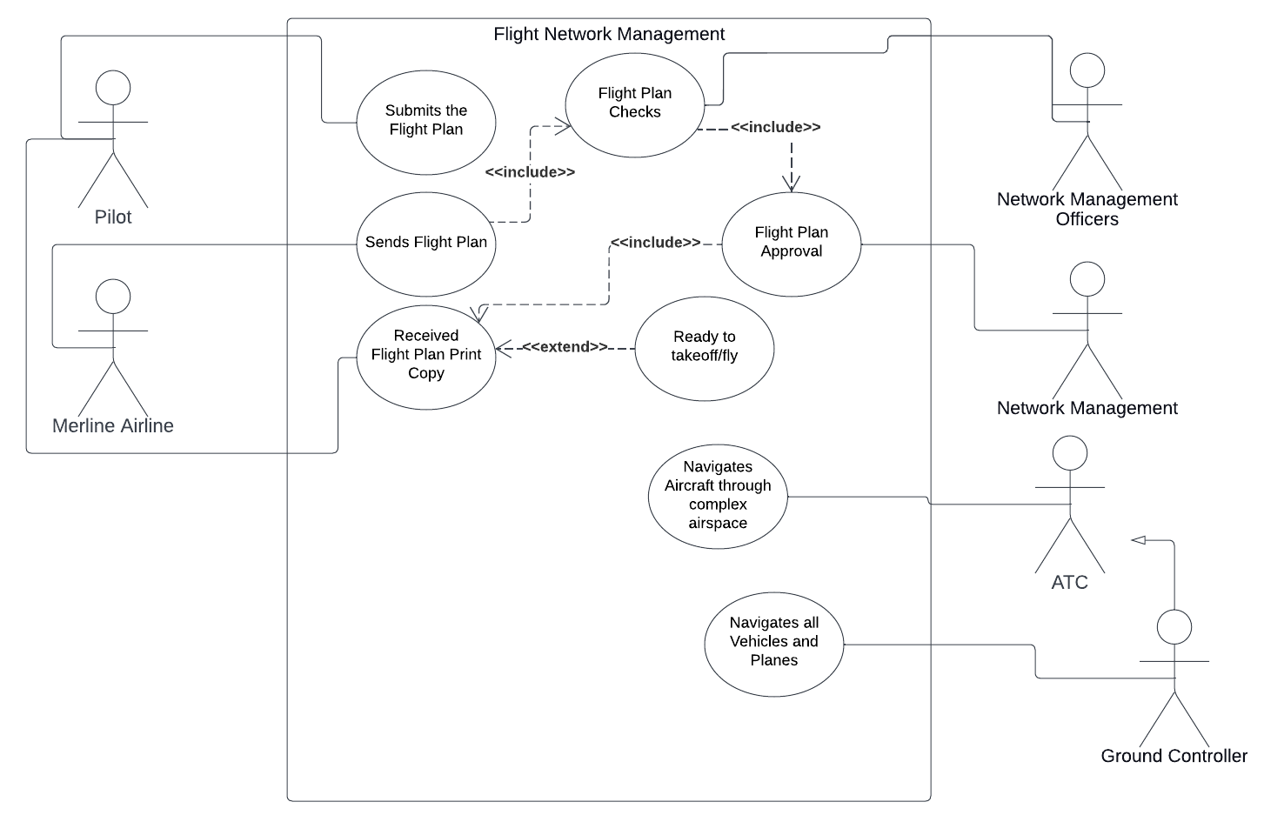

**Sequence Case 2 from scenario:**

In-flight network management system, the pilot first submits his plan. Then the network management officers check the flight plan that the airline sends in and make sure it follows the rules. If it does not follow the rules, it is again sent back to the pilot with the message cause. If the flight plan is approved by network management, then the Pilot receives the print copy and is ready to take off. When the plane is going to take off, the Ground Controller is responsible for navigating all the vehicles and planes safely across the apron up until they reach the runway. As the plane reaches altitude, it will be passed off to the departure airport Terminal Control navigates aircraft through the complex area airspace. Once the plane reaches halfway across, they leave the departure’s air control center and enter the destination air control.

**Sequence Diagram - 2**

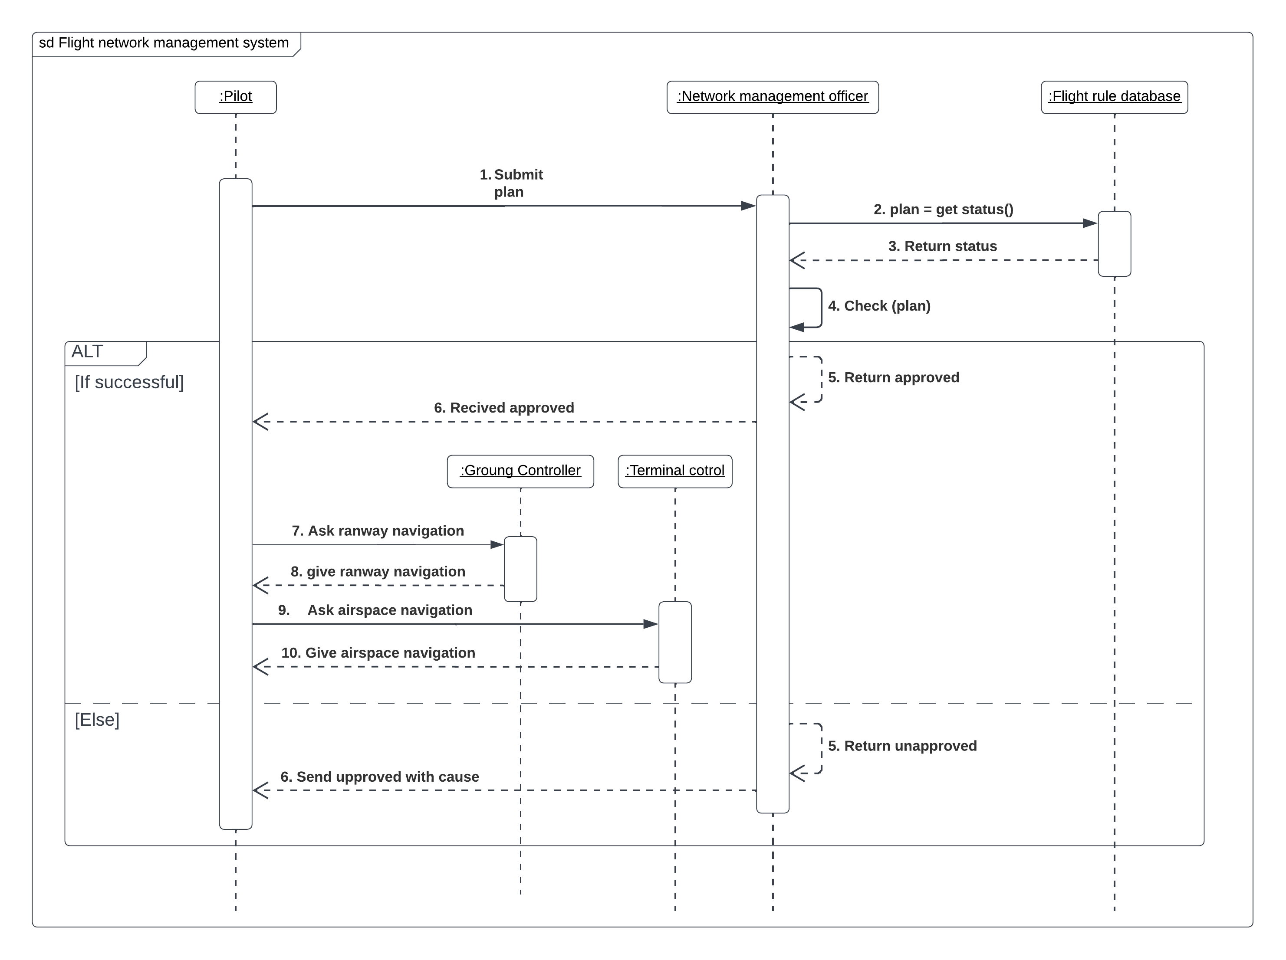

**Activity Case 2 from scenario:**

In-flight network management system, the pilot first submits his plan. Then the network management officers check the flight plan that the airline sends in and make sure it follows the rules. If it does not follow the rules, it is again sent back to the pilot with the message cause. If the flight plan is approved by network management, then the Pilot receives the print copy and the flight plan is saved in a database system at the same time, also plan is ready for taking off. When the plane is going to take off, the Ground Controller is responsible for navigating all the vehicles and planes safely across the apron up until they reach the runway. As the plane reaches altitude, it will be passed off to the departure airport Terminal Control navigates aircraft through the complex area airspace. Once the plane reaches halfway across, they leave the departure’s air control center and enter the destination air control.

**Activity Diagram - 2**

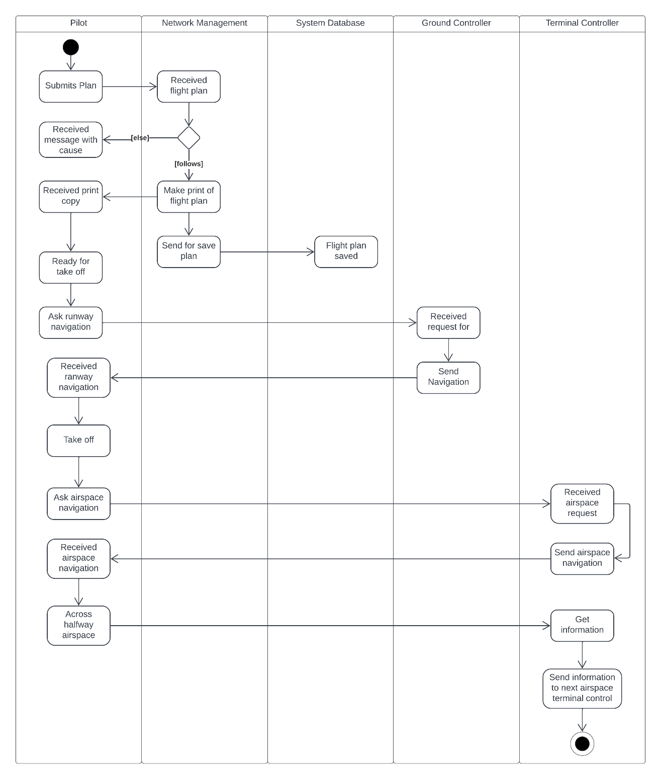

**Scenario-3:**

**Air Traffic Control Management:**

To maintain Flight traffic, Pilots always contact Controllers. Two controllers are working as a team. One overseas talking pilot. The other one is in talking to their counterparts. When a plane arrives in a certain airport’s airspace, it receives info on where and at which flight level it will arrive. They also get info from the flight plan on where it is supposed to exit their sector. An aircraft also might enter at one altitude and be planned to exit at another. The task is then to safely navigate the aircraft from the entry point to the exit point and deliver it to the next sector at the desired altitude. Now, assuming the number of added obstructions such as weather or airspace closures, the main obstacles planes need to avoid at this altitude are other planes. There are rules about how close a plane can be to another to avoid any chance of mid-air collision and the controller’s job is to make sure that these rules are not broken or, if they are, to get the correct separation as soon as possible. An aircraft must be vertically or horizontally separated from all others at any given time. To achieve the goal of getting the aircraft to its exit point without breaking the minimum separation, there are three factors the controller can instruct the pilot to change speed, altitude, and direction. Controllers do to determining where the aircraft needs to go, how to get it there and communicate that to the pilot. Soon enough, after just a few min as the aircraft reaches its exit point from the sector, it will be passed onto the controller of the next sector.

**Use Case 3 from scenario:**

Pilots always contact Controllers. Two controllers are working as a team. One overseas talking pilot. The other one is in talking to their counterparts. When a plane arrives in a certain airport’s airspace, the pilot receives info on where and at which flight level they should go and controllers guide the pilot. Controllers get info from the flight plan on where it is supposed to exit their sector. Controllers guide safely navigate the aircraft from the entry point to the exit point and deliver it to the next sector at the desired altitude. There are rules about how close a plane can be to another to avoid any chance of mid-air collision and the controller’s job is to make sure that these rules are not broken or, if they are, to get the correct separation as soon as possible. When planes exit their sector, they are passed on to the controller of the next sector.

**Use Case Diagram - 3**

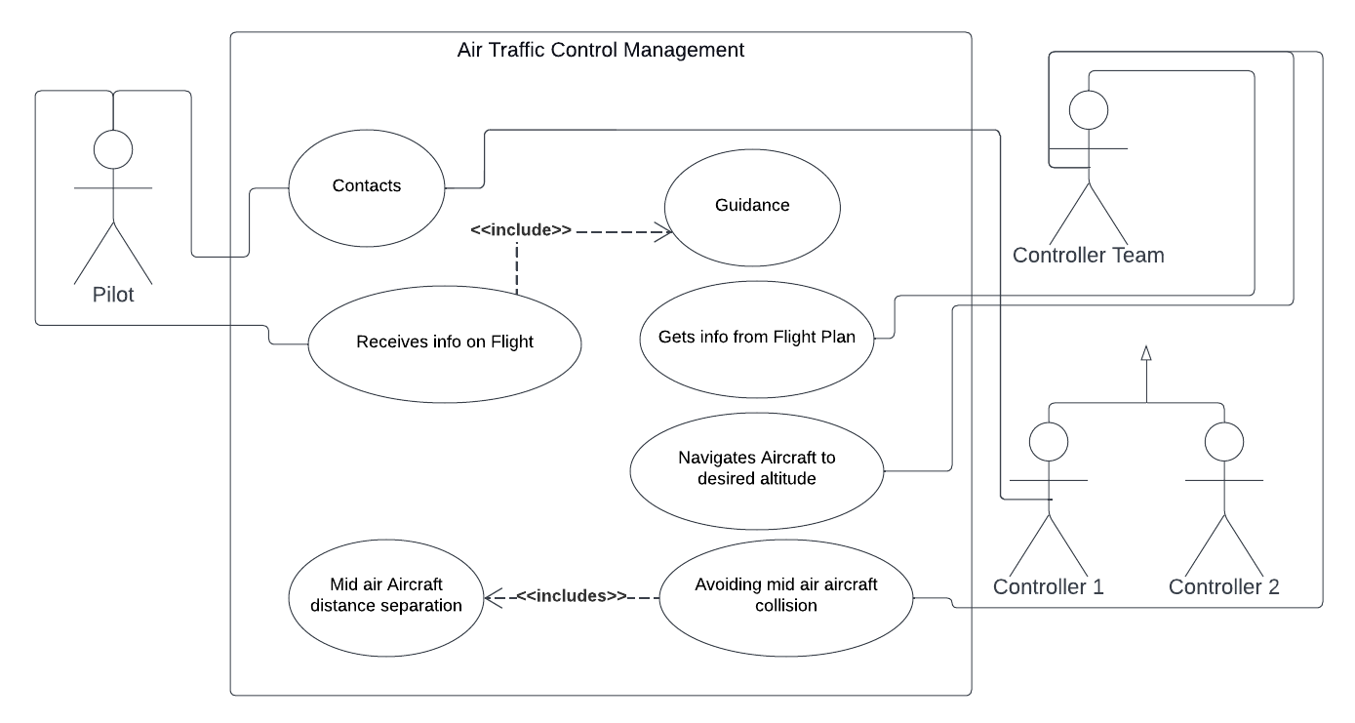

**Sequence Case 3 from scenario:**

In the traffic control system, Pilots always contact Controllers. When a plane arrives in a certain airport’s airspace, the pilot receives info on where and at which flight level they should go and controllers guide the pilot. Controllers get info from the flight plan which is in the flight database. And they get info where it is supposed to exit their sector. Controllers guide safely navigate the aircraft from the entry point to the exit point and deliver it to the next sector at the desired altitude. There are rules about how close a plane can be to another to avoid any chance of mid-air collision. The controller’s job is to make sure that these rules are not broken. If they break the rules, controllers provide the guide to correct separation.

**Sequence Diagram - 3**

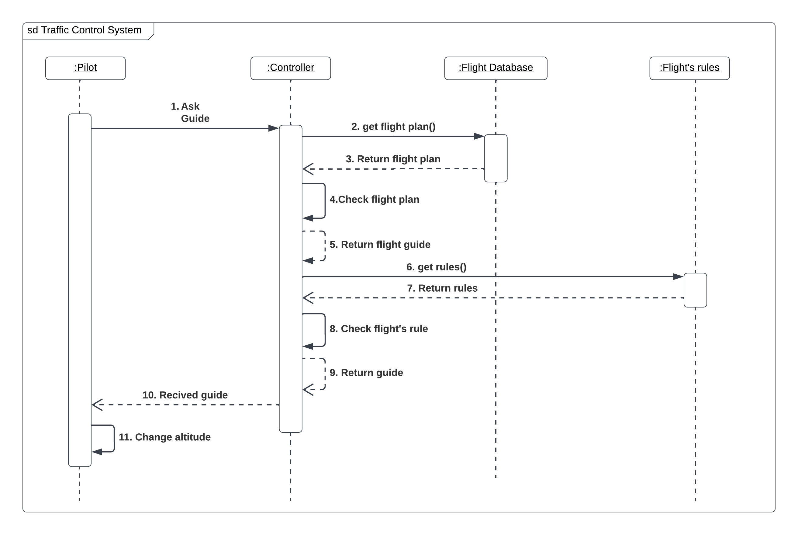

**Activity Case 3 from scenario:**

In the traffic control system, Pilots always contact Controllers. When a plane arrives in a certain airport’s airspace, the pilot receives info on where and at which flight level they should go and controllers guide the pilot. Controllers get info from the flight plan which is in the flight database. And they get info where it is supposed to exit their sector. Controllers guide safely navigate the aircraft from the entry point to the exit point and deliver it to the next sector at the desired altitude. There are rules about how close a plane can be to another to avoid any chance of mid-air collision. The controller’s job is to make sure that these rules are not broken. If they break the rules, controllers provide the guide to correct separation. To achieve the goal of getting the aircraft to its exit point without breaking the minimum separation, there are three factors the controller can instruct the pilot to change speed, altitude, and direction at the same time. Controllers do to determining where the aircraft needs to go, how to get it there and communicate that to the pilot.

**Activity Diagram - 3**

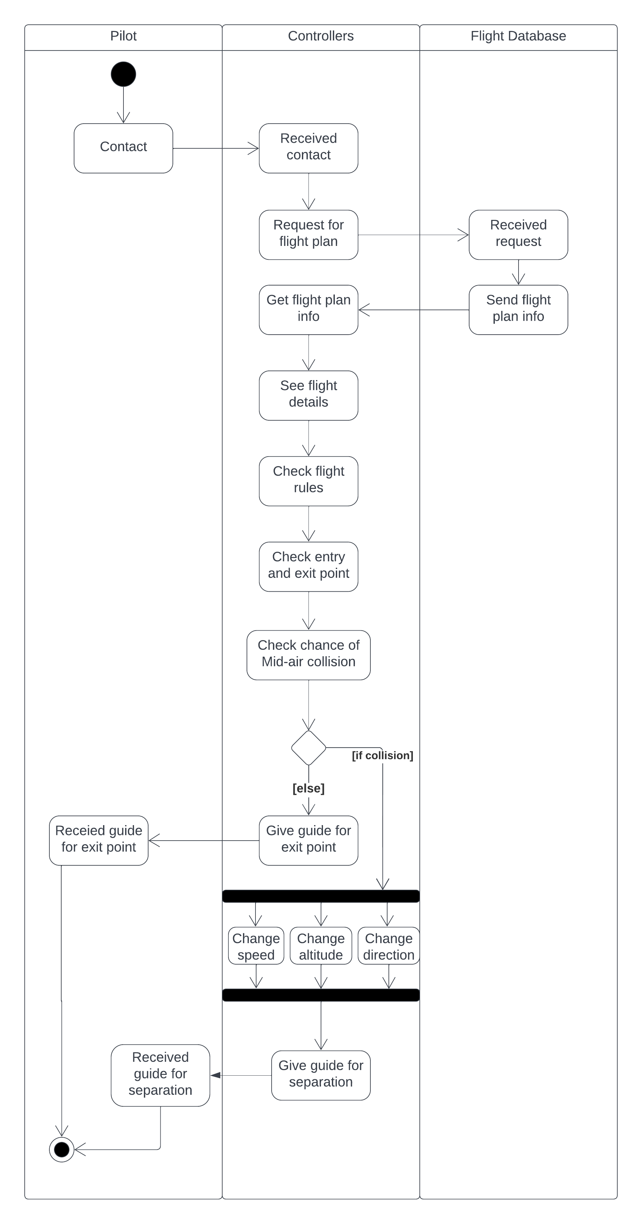

**Scenario-4:**

**Flight handling System:**

As the plane starts to descend it will be passed onto the controllers dealing with lower airspace, then approach and tower control to guide it into landing. Back to the Airport network manager, the second thing they do with the flight plans they receive is to make sure that once an aircraft gets flying, there are enough air traffic controllers to manage it. Air traffic controllers decide how many aircraft they can handle based on their infrastructure, and their tools. If there is not enough traffic controller to maintain the aircraft then the Plane would be delayed. Harsh weather is also one of the reasons for delays. When a flight receives a delay by Air Traffic Controller, the airline has two choices – accept ta delays and wait for it out OR fly a different route. Airlines have access to the Air control system and help them make this decision. If the flight chose a different route, then they decide the route which is best for them.

**Use Case 4 from scenario:**

In a flight handling system, Airport network managers are to make sure that once an aircraft gets flying, there are enough air traffic controllers to manage the flight plans they receive. Air traffic controllers decide how many aircraft they can handle. In this system, if there is not enough traffic controller to maintain the aircraft then the Plane would be delayed. When a flight receives a delay from the Air Traffic Controller, the airline has two choices – accepting delays and waiting for them out or flying a different route. Airlines have access to the Air control system and help them make this decision. If the flight chose a different route, then they decide the route which is best for them.

**Use Case Diagram - 4**

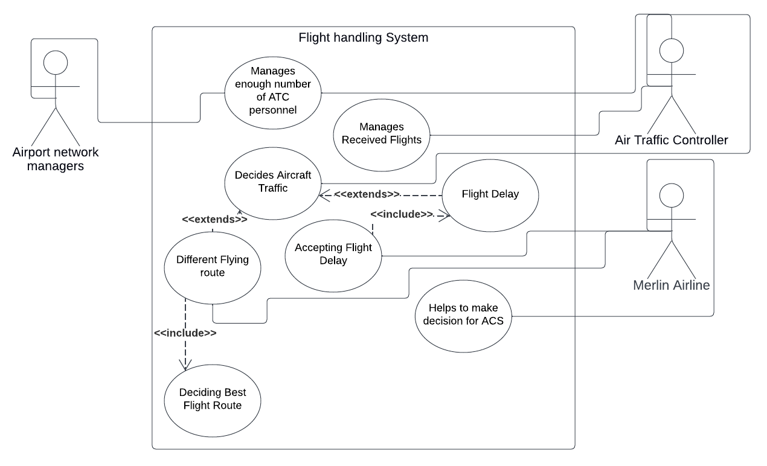

**Sequence Case 4 from scenario:**

In a flight handling system, Airport network managers are to make sure that once an aircraft gets flying, there are enough air traffic controllers to manage the flight plans they received from the pilot. Air traffic controllers decide how many aircraft they can handle based on their infrastructure, and their tools. If there is not enough traffic controller to maintain the aircraft then the Plane would be delayed. When a flight receives a delay from the Air Traffic Controller, the airline has two choices – accepting delays and waiting for them out or flying a different route. Airlines have access to the Air control system and help them make this decision. If the flight chose a different route, then they decide the route which is best for them.

**Sequence Diagram - 4**

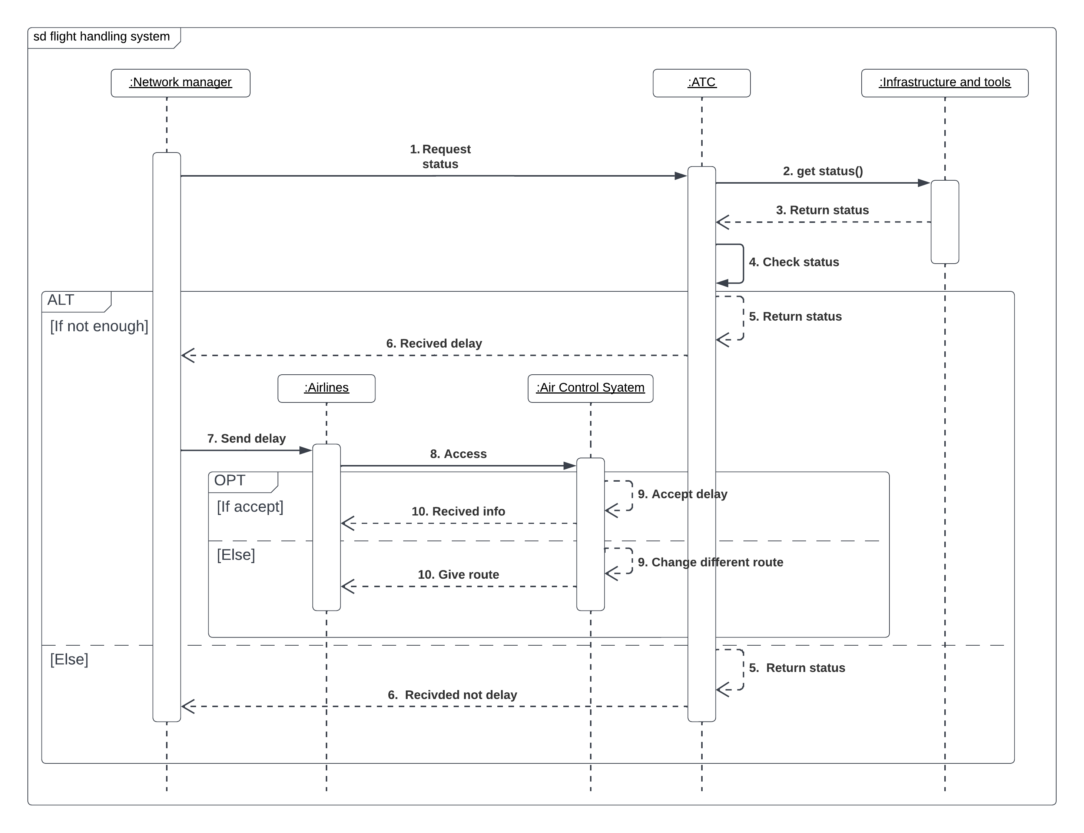

**Activity Case 4 from scenario:**

In a flight handling system, Airport network managers are to make sure that once an aircraft gets flying, there are enough air traffic controllers to manage the flight plans they received from the pilot. Air traffic controllers decide how many aircraft they can handle based on their infrastructure, and their tools. If there is not enough traffic controller to maintain the aircraft then the Plane would be delayed. Then they change the flight schedule and send the information about delays to the airlines at the same time. When a flight receives a delay from the Air Traffic Controller, the airline has two choices – accepting delays and waiting for them out or flying a different route. Airlines have access to the Air control system and help them make this decision. If the flight chose a different route, then they decide the route which is best for them.

**Activity Diagram - 4**

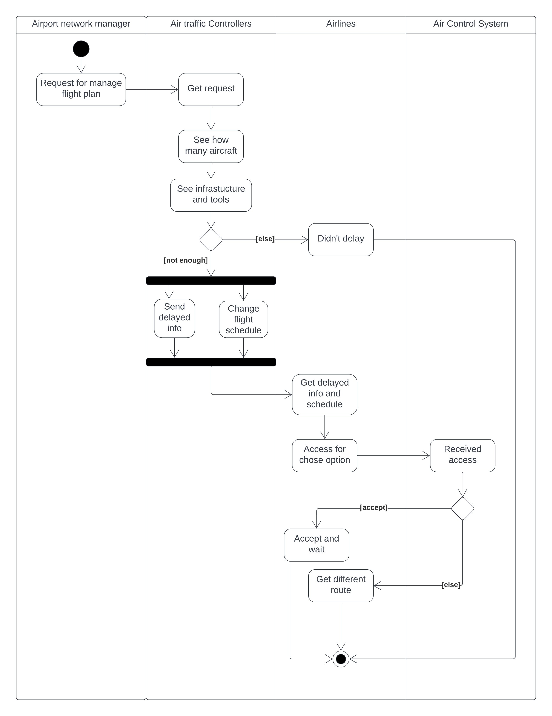

**Scenario-5:**

**Flight Survey System:**

In May 2017, the Aero Scientific division of Merlin Airlines and world-leading camera manufacturer Hasselblad jointly launched the newest medium format aerial mapping system with advanced airborne imaging technology to win special Government contracts associated with Military Surveillance Operations. The system features the new 100-megapixel Hasselblad A6D, the award-winning Aero Scientific Aviatrix Flight Management System (FMS), the Flight-Cube computer, as well as all the other peripheral devices. This advanced FMS is quite different than Merlin's typical covert aircraft's FMS. This new system is portable, lightweight, and convenient whilst also being incredibly technologically advanced, making it the perfect system for all aerial photographic needs. The camera is placed under the cockpit area of the plane. Aero Scientific Aviatrix Flight Management System (FMS) provides an aerial mapping solution that is far superior to Merlin's technology and the cost-effective solution that the company was looking for. This FMS integrates with GPS (Global Positioning System) and IMU (Inertial Measurement Unit) with the camera's stabilized and non-stabilized mounts. Here the FMS has a single screen CDU (Control Display Unit) and gives full control over navigational data, Camera triggering, and other settings. The camera offers natural RGB color and NIR(Near-infrared). This special combined device offers features such as flight planning, capturing images, and logging meta flight metadata in a range of formats and can be used in a variety of aircraft like gyrocopters, light sport aircraft to heavy twins. The system records metadata for every image that is captured with GPS and IMU logs of every flight.

A Cessna 206 VH-KPG is modified for survey flights and the Hasselblad camera is placed under the cockpit area. The pilot from Brisbane Airport has been assigned to complete the survey of various parts of Queensland surveying high-voltage power lines

and infrastructure within a four-hour flight. A stabilizer mount is used for the camera. The first shot was taken in the first 1 second for a quick view. The main camera has additional lenses for in-depth measurement and detailed imagery. Extra zooming is used for serial number capture. The modified FMS shows information in the single screen CDU (Control Display Unit) about altitude, camera serial numbers, aircraft information, exact time of each photo taken, sun angle of the photo, etc. as the pilot switches settings to view. The camera was calibrated to collect panchromatic, RGB, and infrared

at the same time as the client requested the footage. Especially the infrared feature allows the pilot to see wetlands, shadowy places, other lower light conditions, etc. The software of these FMS (Flight Management System) is always up to date as Merlin Company promises.

**Use Case 5 from scenario:**

Merlin Aerial Survey Program is now providing an easy solution to Aerial mapping and survey. There are several pilots and engineers for every flight session. Clients can request any specific aerial survey. Flight footage is recorded in a session. A recording session is usually done by the pilot or engineer on board. Before any recording, the camera needs to be adjusted according to the survey type by the engineering crew. All session requests are verified by the company's survey division. The company maintains a list of preferred clients where there can be special clients from the Military or Civil. According to the client's need, the flight time for every footage capture is decided by the company survey team. For every session, the pilot always submits flight plans and stays connected to ATC (Air Traffic Control). The engineer controlling the camera sets the suitable settings that are required for every session. He must notify the pilot if any area needs additional in-depth mapping and then the pilot must go through the area again as he adjusts altitude and other settings in the FMS.

**Use Case Diagram – 5**

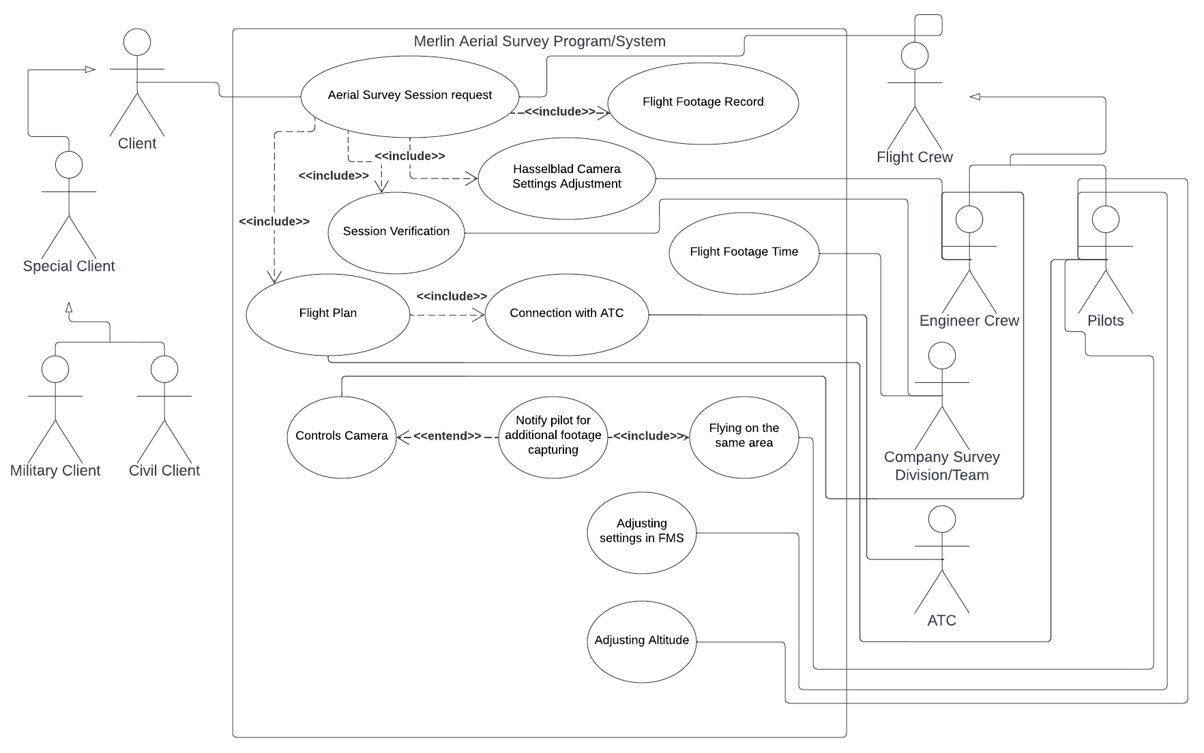

**Sequence Case 5 from scenario:**

Merlin Aerial Survey team sets the instruction on how the survey should be conducted according to the client's needs. Then the instruction is passed to the pilot. The pilot discusses the instructions with the crew for the flight session and sets the flight plan accordingly. The engineers set the camera settings according to the instructions. The operator of the camera switches settings for each footage like zooming, color mode, angle, etc., and checks metadata in the display. During the flight, the pilot asks for the flight to follow instructions to the ATC (Air Traffic Control) through radio. Finally, all footage data is saved in the Hasselblad Drive.

**Sequence Diagram - 5**

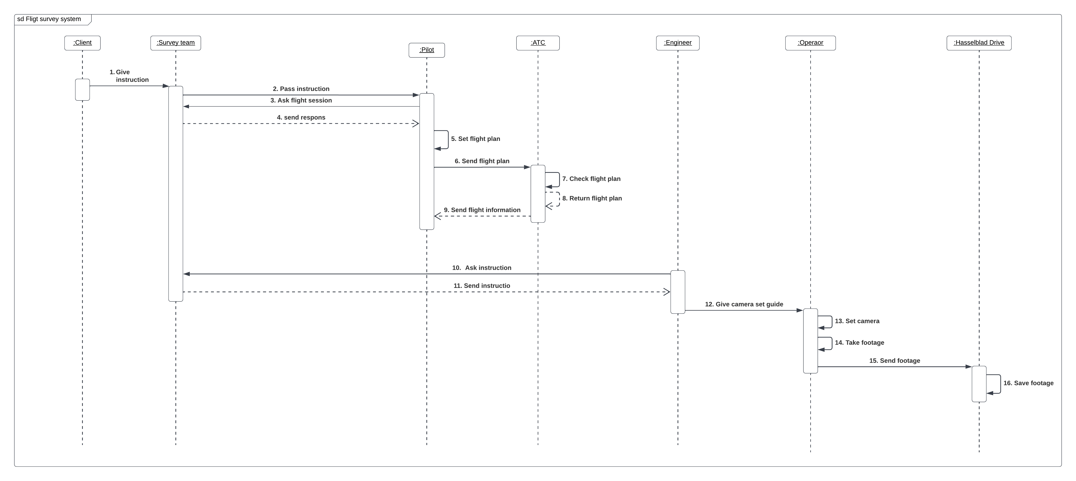

**Activity Case 5 from scenario:**

In the Merlin Aerial Survey Program, a client places a request to the company for a specific aerial survey. The survey system gets all available aircraft information and flight crews. Once the aircraft and crew information of availability is received, the system organizes the survey session. Specific options about cost, time, aircraft type, and survey type are presented to the client. If the client likes and chooses the options, then the request is confirmed. The client can cancel the request. After the request is verified by the system, the system sends instructions to the flight crew. The engineer and technicians check the aircraft's condition and the team checks the weather and other parameters. The system sends a green signal if an ideal condition for the survey is found and notifies the flight crew. When instructions and approval by the system are given, the flight crew initiates the survey flight.

**Activity Diagram – 5**

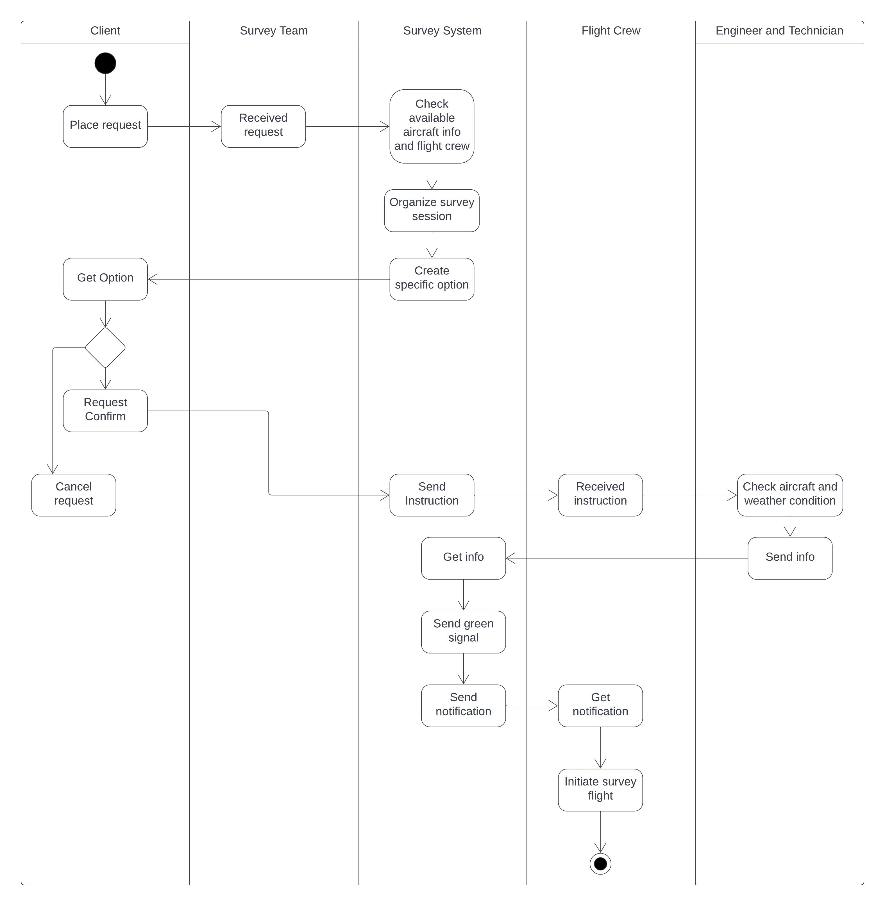

**Scenario-6:**

# FMC of FMS troubleshooting:

These basics are taught in Merlin Aviation Systems Training. The training is about interpreting failures associated with Merlin Aviation's Boeing 737 (FMC) flight management computer. Typical passenger aircraft have dual FMC installed. Here, the instructor's goal is to educate technicians on interpreting the differences between FMC (hardware fault and software fault), and downloading log file from FMC if a software fault is suspected. If a software fault has been identified, then that downloaded log file will need to be sent to Merlin Aviation for further analysis. If a hardware fault is identified, then the FMC box will need to be removed from the aircraft and sent to Merlin Aviation for further testing and repair. The FMC is a digital computer designed for use with a variety of aircraft avionics equipment. The main function of the FMC is to provide automatic navigation and guidance as well as control and monitor aircraft performance. It also detects failure and saves logs of all monitoring data. Also, it has BIT (Built-In-Test) and BITE (Built-In-Test-Equipment). By design, Boeing 737 FMS is designed to operate with either a single or dual FMC and with either a single or dual CDU (Control Display Unit) configuration. Usually, in a dual-mode configuration, one FMC flies the airplane while the other FMC provides backup. The FMC that is flying the aircraft is designated as the primary FMC while the backup FMC is designated as the secondary FMC. Although the secondary FMC does not fly the aircraft but performs the same computations as the primary one and uses those computations for comparison purposes. If the primary FMC fails, the secondary FMC is readily available to take command and fly the aircraft. The FMC monitor is implemented by two CDUs (Control Display Unit) that display pages of flight-related data. The keyboard in front of the CDU allows the crew to make edits to the flight data. Maintenance functions and lug fault information can also be accessed by the CDU. While software exceptions can occur, the FMC is designed to handle such events without the user being aware of any operational issues. Occasionally some exceptions need to be handled by an FMC reboot, after a reboot, the FMC returns to normal operations. If the primary FMC restarts, both primary and secondary CDUs will blank out for approximately 30 seconds. This blanking of the CDUs often gets misunderstood as an FMC fault, leading to the FMC being removed needlessly from the aircraft for repair. At the repair shop, this type of fault results in a (no fault found) in testing, and a recertification fee is added to the bill. The maintenance technician can avoid this through proper fault diagnosis. BIT(Built-In-Test) functionality continues to check the operational status of the FMCs (Flight Management Computer) (Flight Management Computer) (Flight Management Computer) and CDUs throughout the flight. BIT functions also check the operational status of the aircraft sensor systems interfacing with the FMC. Through these checks, the BIT provides a log of any failures that may have occurred both hardware or software related. BIT results can then be accessed and viewed by a line maintenance technician for further investigation. Fault logs provide more detailed information about any failure that can be downloaded and sent to Merlin Aviation for more detailed analysis.

**Use Case 6 from scenario:**

During FMC (Flight Management Computer) troubleshooting it is mandatory to carefully diagnose the FMC box using the training manual. The technician can diagnose the problem using the manual or may call the available line maintenance technician for further checking for a complex case. Because ensuring the safety of FMS equipment is a top priority of the company. Technician checks for all Hardware and Software issues in the FMC. The technician uses the BITE(Built-In-Test-Equipment) function to analyze the aircraft performance and other conditions through scanning. If any software error is found, he tries to restart the FMC. If any fault is found, FMC itself writes a fault log and shows it to the technician through CDU (Control Display Unit). If a hardware fault is severe, the technician sends the faulty FMC box to the repair shop of another company and orders a repair and recertification of equipment. For design flaws in the Hardware and Software of FMC, the equipment is then sent to Merlin Aviation Division for further detailed analysis, testing, and repair.

**Use Case Diagram - 6**

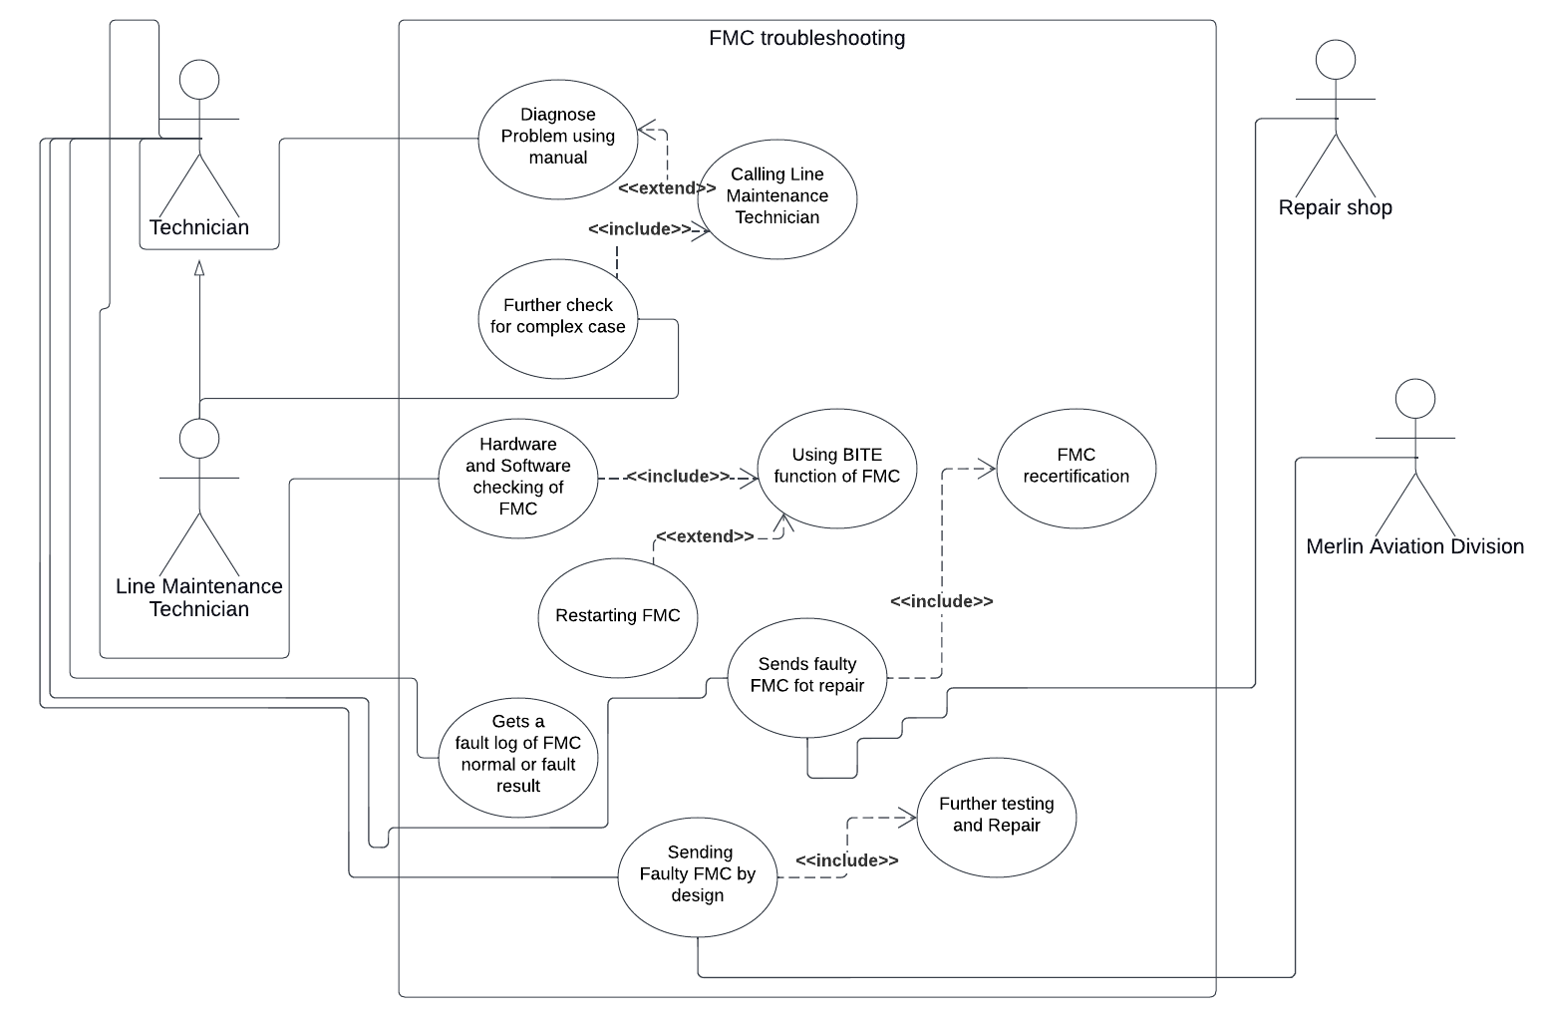

**Sequence Case 6 from scenario:**

Merlin Aviation Department includes instructions about troubleshooting an FMC (Flight Management Computer) as FMC and other pieces of equipment require additional fault checking and troubleshooting. The instruction manual is then passed down to a set of technicians. The technician checks and lists those types of equipment that need additional checking. Critical components like FMC and other parts are then extracted from the list. A set of Technicians check the hardware faults of the FMC and others diagnose software parts. Technicians sent FMC to the line maintenance technicians for further checking. Technicians look for fault log in BITE

(Built-In-Test-Equipment) scanning inside FMC. FMC also creates and saves fault logs and technicians can download them from FMC. Faulty FMC is sent to repair shops with fault logs for recertification and repair. The repair bill is then sent to the technicians by the Repair Company.

**Sequence Diagram - 6**

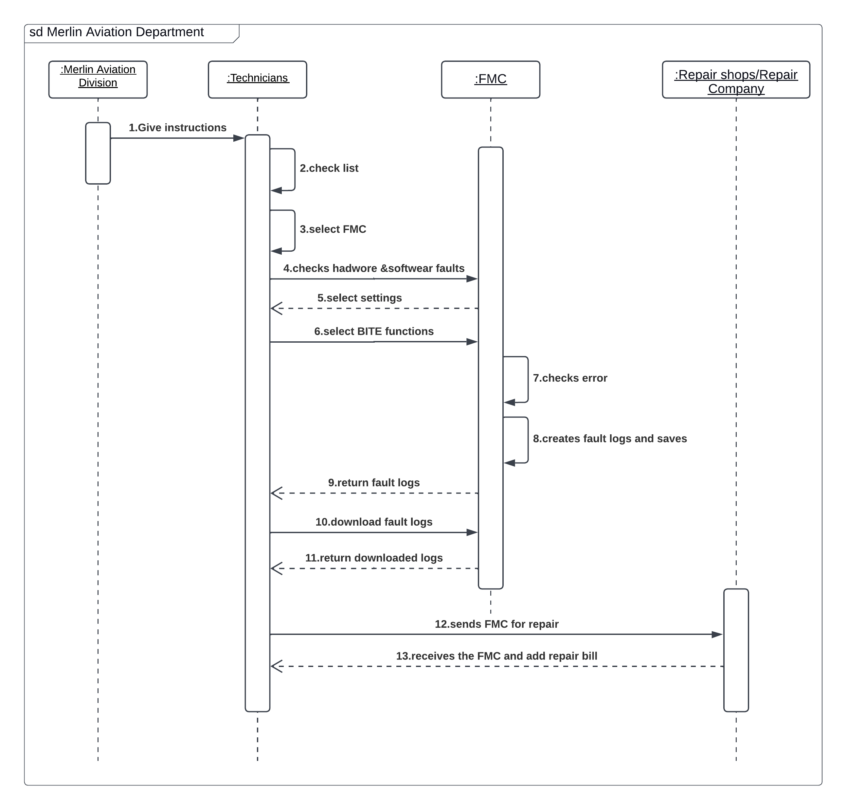

**Activity Case 6 from scenario:**

In an FMC (Flight Management Computer) troubleshooting session, a technician is diagnosing FMC through its interface. Through the interface, the technician enables the BITE(Built-In-Test-Equipment) function in the FMC and waits. While the technician is waiting, FMC creates a session object which requests conditions of plane sensors and other types of equipment. The list is then shown to the technician. The technician selects a specific sensor from the list and the session object retrieves the details of the sensor. Any fault of the sensor that is detected by the session object, it writes the details of the fault in the fault log and shows it to the technician at the same time. After saving the fault log, FMC moves it to the download section for technicians.

**Activity Diagram - 6**

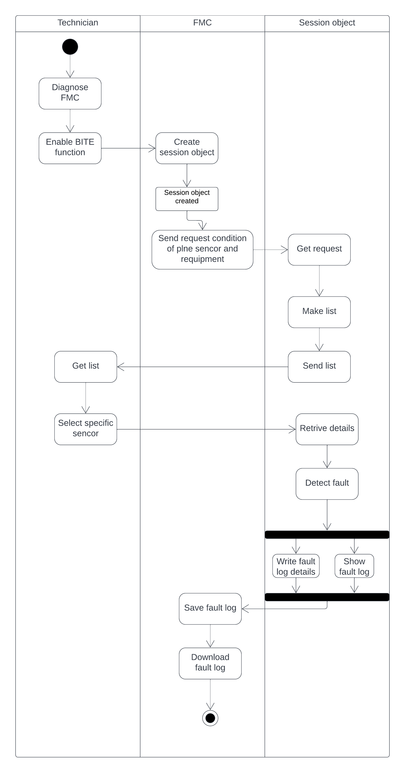

**Scenario of Class Diagram:**

In Merlin Flight Management System, we attached a small number of classes as Main System in real life is a lot complex and diagram is not compact or easy to comprehend. Starting with the "Merline Airlines Employee" class it is the superclass of most of the classes shown here. It has 4 administrative bodies from ATC (Air Traffic Control), AOC (Aircraft Operation Center), and FSS to Aviation Division. Each administrative class has its specialized employees. All are shown with dependencies and relation-based multipliers. The Client class is just attached with Association with Aviation Division and Aerial Survey Division. In the entire system, there are no zero employees or client case in the relationships. Several types of multipliers are used here with a special type of associations called Aggregation and Composition and with Generalization. The core flight management system components are linked with the Pilot and Repair- Maintenance class. Other components and parts are just to complete the works of Flight Plan and its association with Flight Management Systems. Here every administrative body holds [1] to [many] employees. Except for the FMS (Flight Management System), as it can have zero or more maintenance linked with Maintenance Team. Micro class case and other components are not necessary here as it tends to show more complexity overall. The other exception in the relationship is for the FMS. Most small aircraft have Single FMC (Flight Management Computer) and a few CDU (Control Display Unit), combined as FMS. A passenger-based or special category has dual FMC and Multiple CDU or MCDU (Multipurpose Control and Display Units) setups. Thus, specific number-based multipliers are used. Before accessing the FMS, the Pilot must have an Account, and other administrative bodies coordinate directions and decisions to complete a flight plan that the Electronic Brain of the Aircraft or FMS follows. This is the overall scenario.

## Class Diagram

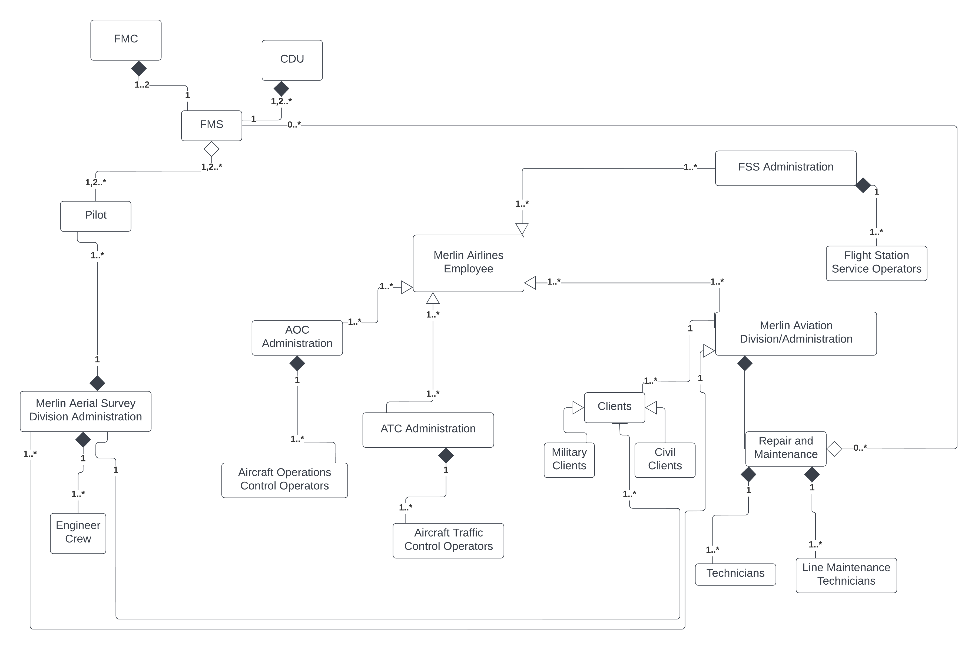

**Class Notation of some main components**

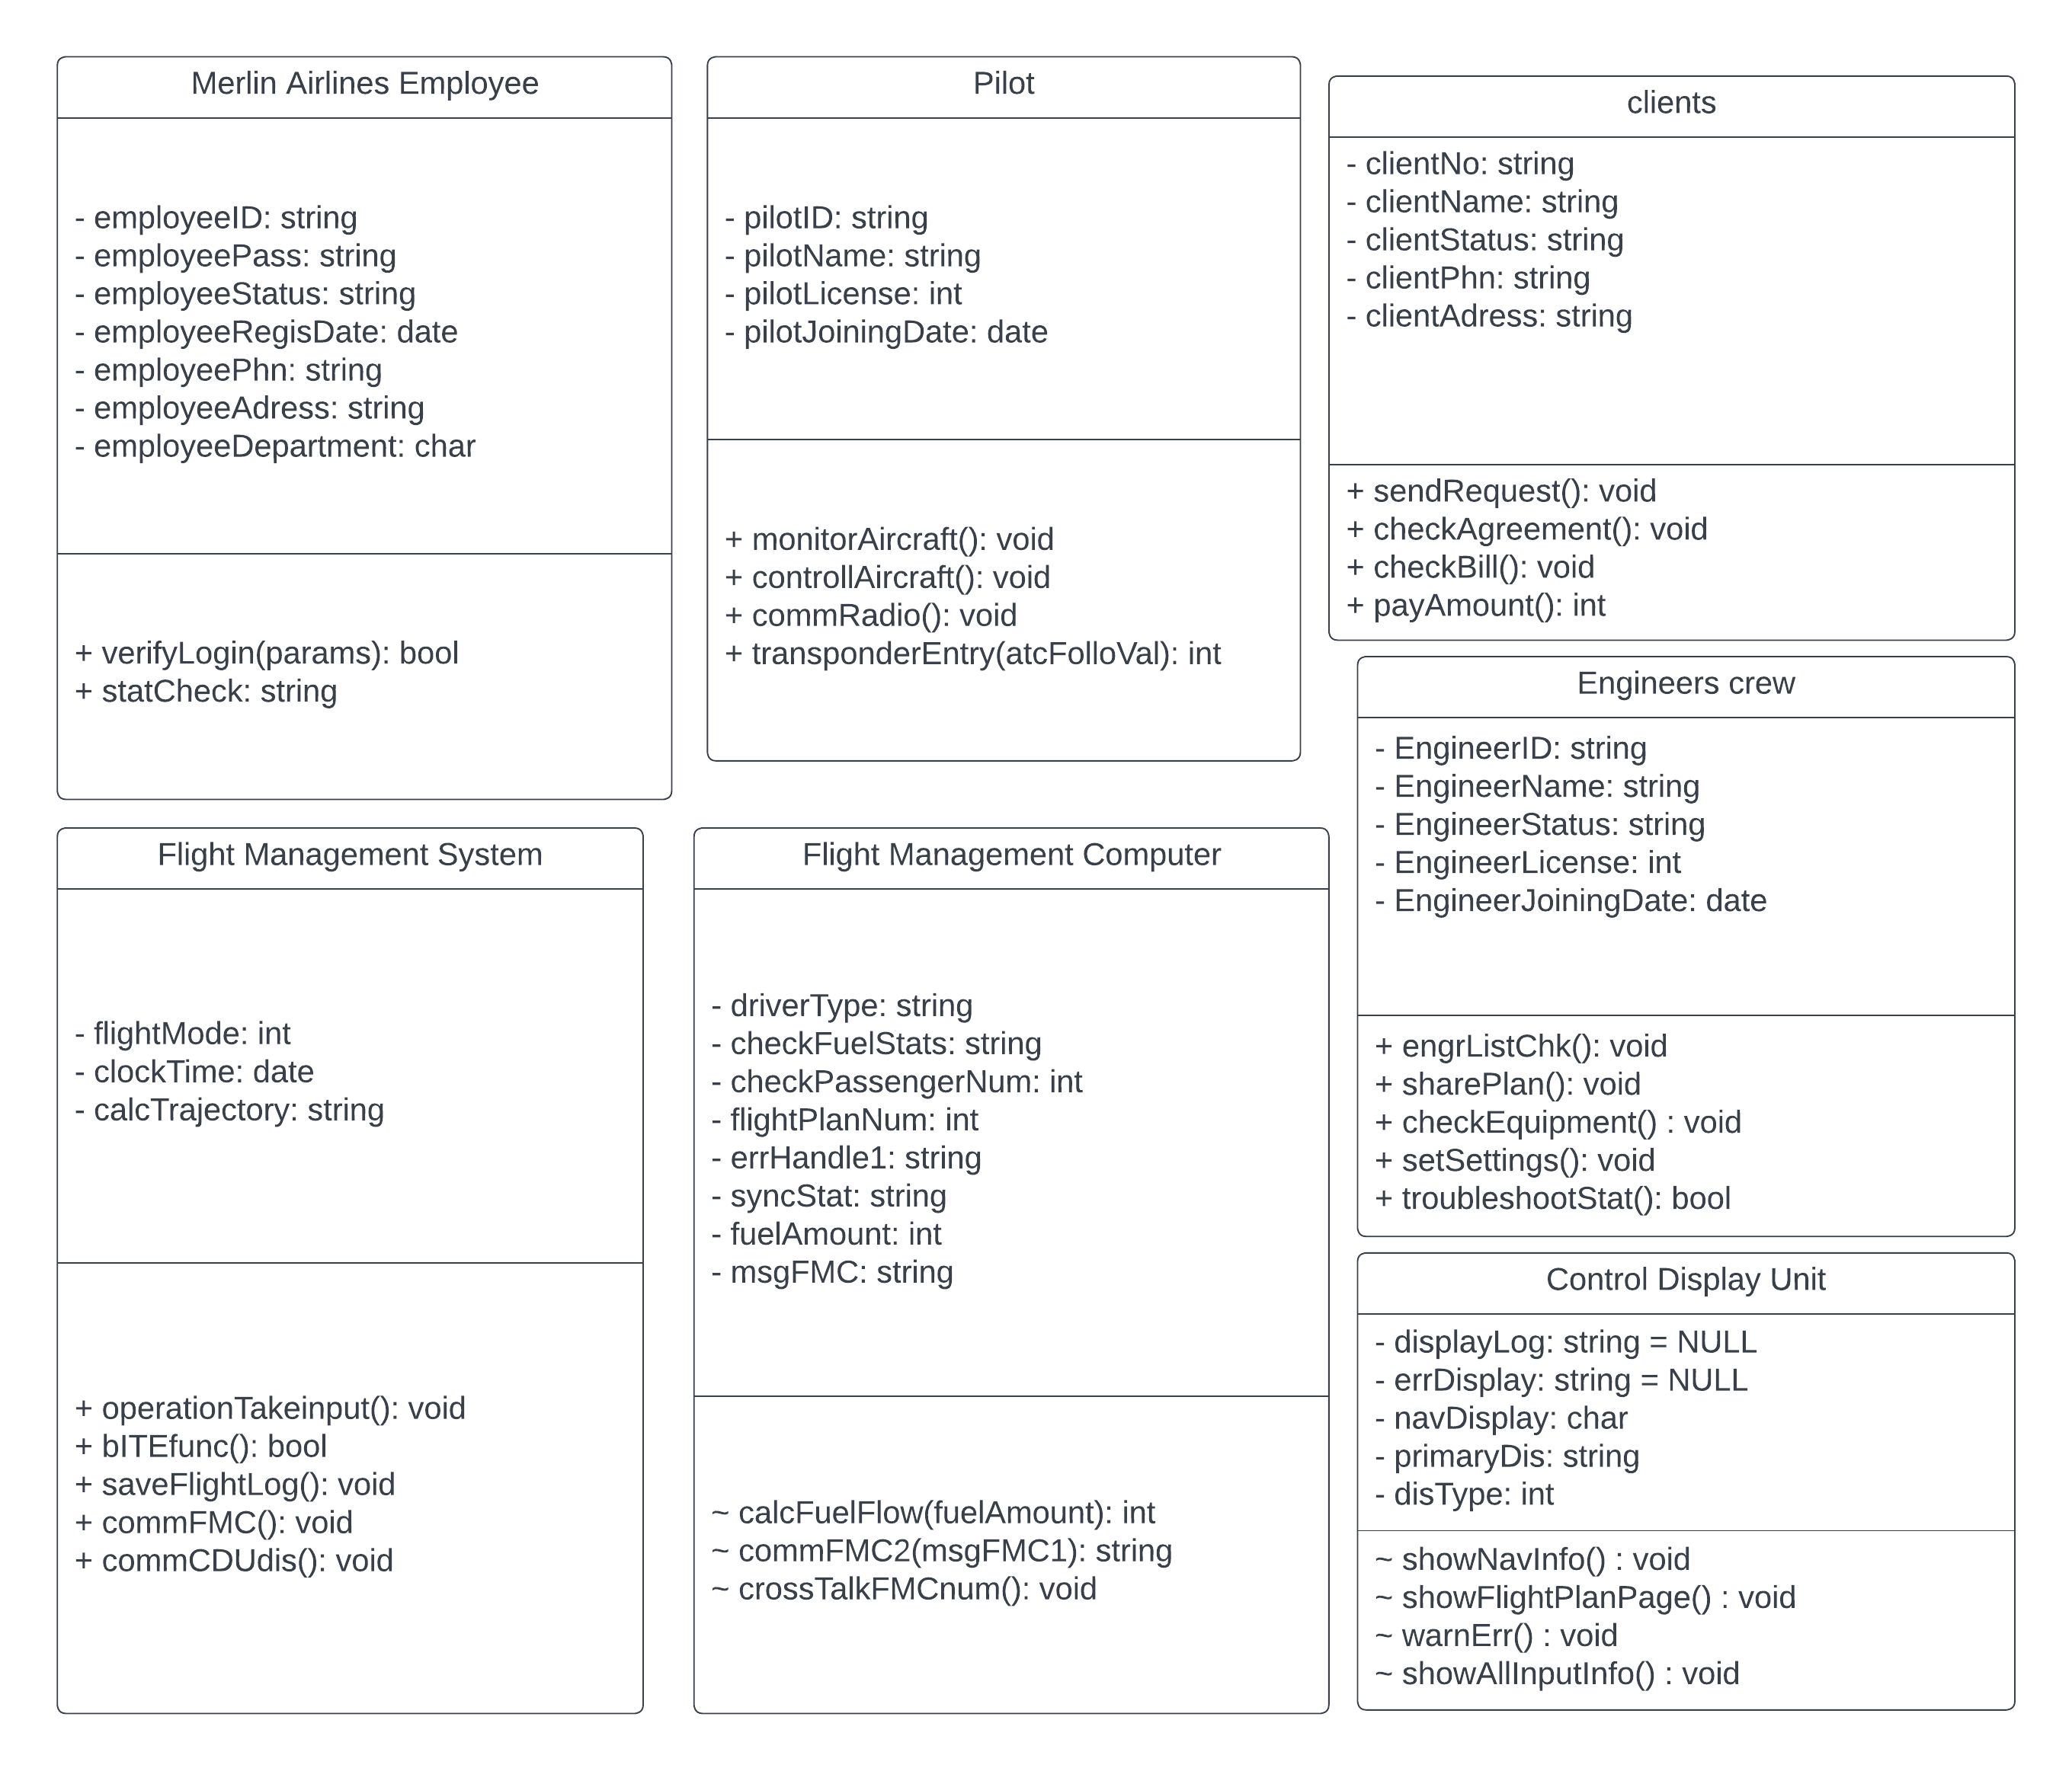

## Conclusion:

A Flight Management System (FMS) is on-board multi-purpose navigation, performance, and aircraft operations computer that provides virtual data and operational harmony between closed and open aspects connected with a flight, from pre-engine start and take-off through landing and engine shut-down. To fulfill current and future airspace management criteria,

Most current commercial and business planes are outfitted with an Electronic Flight Instrument System (EFIS), which replaces analog systems and flight deck displays used in WWI and WW2. The Merlin Flight Management System upgrade enhances operational flexibility and dependability, improves dispatch and on-time arrival availability, simplifies maintenance, and improves safety by improving situational awareness and reducing crew effort. The advancement of FMS reduces the cost of gaining other capabilities even further.

Advance designs are introduced in such a manner that fleet owners, governments, and investors may invest with confidence, and so Merlin FMS works as promised and delivers a considerable return on investment, confirming human and cargo safety and flying with confidence.

## Reference:

* Deshmukh, Ajinkya. "Flight Management Systems." *Studylib.net*, 1 May 2022, studylib.net/doc/25381353/flight-management-systems-. Accessed 1 May 2022.
* Productions, Wendover. “How Air Traffic Control Works.” *Www.youtube.com*, Wendover Productions, 18 June 2019, www.youtube.com/watch?v=C1f2GwWLB3k&list=PLNBf2H2kcmIL4lDc7Ol9LAHZe7EcSKn88&index=20.
* ‌ Droid, Curious. “Merlin - the Engine That Won the War.” *Www.youtube.com*, Curious Droid, 29 Sept. 2019, www.youtube.com/watch?v=baDZSADYbNM&list=PLNBf2H2kcmIL4lDc7Ol9LAHZe7EcSKn88&index=17. Accessed 3 May 2022.

‌

* Avery, David. "The Evolution of Flight Management Systems." *IEEE Software*, vol. 28, no. 1, Jan. 2011, pp. 11–13, 10.1109/ms.2011.17. Accessed 16 Nov. 2019.
* "Next Generation Flight Management System." *Innovative Solutions & Support*, innovative-ss.com/products/flight-management-system/next-generation-flight-management-system/. Accessed 1 May 2022.
* "Flight Management System." *SKYbrary Aviation Safety*, 27 May 2021, skybrary.aero/articles/flight-management-system.
* Aviation, General Electric. "TrueCourse Flight Management System." *Www.youtube.com*, 7 July 2016, www.youtube.com/watch?v=GZsbNNiB1L4. Accessed 1 May 2022.
* Aviation, General Electric. "Connected Flight Management System: A Powerful Solution in Every Phase of Flight." *Www.youtube.com*, 2 May 2018, www.youtube.com/watch?v=DYBCt-If4i4. Accessed 1 May 2022.
* “B737 - FMC Troubleshooting - GE Aviation Maintenance Minute.” *Www.youtube.com*, www.youtube.com/watch?v=gcBQQgpxCPU&list=PLNBf2H2kcmIL4lDc7Ol9LAHZe7EcSKn88&index=1. Accessed 3 May 2022.
* “Geofly | One Day of Aerial Survey Operation.” *Www.youtube.com*, www.youtube.com/watch?v=9wDmG4kD41o&list=PLNBf2H2kcmIL4lDc7Ol9LAHZe7EcSKn88&index=3. Accessed 3 May 2022.
* “How to File & Activate a Flight Plan, and Request Flight Following.” *Www.youtube.com*, www.youtube.com/watch?v=duJPe2p6m0g&list=PLNBf2H2kcmIL4lDc7Ol9LAHZe7EcSKn88&index=8. Accessed 3 May 2022.
* “Introducing AeroScientific’s Flight Management System.” *Www.youtube.com*, www.youtube.com/watch?v=665vjNf_bb4&list=PLNBf2H2kcmIL4lDc7Ol9LAHZe7EcSKn88&index=5. Accessed 3 May 2022.
* “Keystone Aerial Surveys: I Fly UltraCam.” *Www.youtube.com*, www.youtube.com/watch?v=dNID6EbzTrE&list=PLNBf2H2kcmIL4lDc7Ol9LAHZe7EcSKn88&index=2. Accessed 3 May 2022.